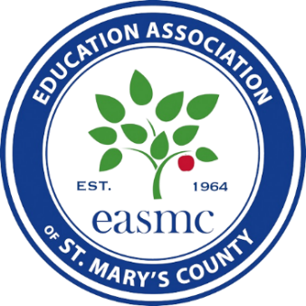

2026 Board of Education Candidate Questionnaire

CANDIDATE:

OFFICE SOUGHT:

CAMPAIGN ADDRESS:

PHONE NUMBER(S):

CAMPAIGN EMAIL:

CAMPAIGN WEBSITE:

I confirm that the responses provided here are my official positions in seeking local office and I understand that EASMC reserves the right to share my responses with members and interested parties.

CANDIDATE SIGNATURE: DATE SUBMITTED:

Candidates: To be considered for a recommendation, you must indicate your response to each of the questions. You may use more space than is provided to elaborate on your answers and provide clarification, explanation, and other context, but please be certain to clearly indicate the questions(s) to which you refer. Please return your completed and signed questionnaire to EASMC.

Education Funding and Collective Bargaining:

- How would you solve the workload crisis facing educators and support staff in our schools?

- Districts across the county are working to recruit and retain diverse educators that reflect the students they work with. How will you address educator recruitment and retention?

- As a member of the Board of Education, how do you balance honoring ratified contracts with other priorities, especially in tight fiscal times?

- As a member of the Board of Education, will you ask the local funding authority for resources that school district needs or the funding you think the district is likely to receive?

- The Education Support Professional (ESP) Bill of Rights calls for livable wages so that ESPs: don’t have to work multiple jobs; can access secure retirement and affordable healthcare; are assured of workload and staffing levels that allow them to succeed; are guaranteed safe and healthy work environments; have their job security protected against privatization, and more. If elected to the Board of Education, how will you work to make this a reality for support staff in our schools?

Curriculum:

- How will you support diversity, equity, and inclusion for all students throughout the county? What specific policies do you support regarding equitable access, opportunities, resources, and supports?

- Do you support or oppose a curriculum that reflects the perspectives and backgrounds of diverse learners? How would you respond to families and public groups requesting changes to content and curriculum?

- EASMC supports honesty in education. To encourage critical thinking, we believe educators should have professional autonomy and should be afforded the deference to teach the truth in their classrooms, schools, and districts. Do you support or oppose this position? Why?

Support and Community Support:

- If the federal government cuts funding to Title 1, free and reduced meals, and special education, how will you help students who rely on these programs?

- How will you address the increased need for services to support the mental health and well-being of students in our school system?

- What policies and procedures should our district adopt to ensure that school personnel follow a consistent, legally sound process when approached by immigration law enforcement agents, while minimizing disruption to the learning environment and protecting students and families?

- Do you support or oppose local efforts to create and support community schools? Why?

